Project Planning Template

Parameter | Details
Date | 18 June 2026
Team ID
Project Name | Book A Doctor
Maximum Marks | 5 Marks

____________________________________________________

Product Backlog, Sprint Schedule, and Estimation:
Use the below template to create product backlog and sprint schedule

Sprint | Functional Requirement (Epic) | User Story Number | User Story / Task | Story Points | Priority | Team Members
Sprint-1 | User Authentication & Profiles | USN-1 | As a user, I can register by entering my name, email, password, and selecting my role (Patient/Doctor) so that I have a personalized account. | 3 | High | Dev-01
Sprint-1 | User Authentication & Profiles | USN-2 | As a user, I can log in using my email and password to securely access my specific landing page dashboard. | 3 | High | Dev-02
Sprint-1 | User Authentication & Profiles | USN-3 | As a logged-in user, I can update my profile details (phone number, address, and specialization fields for doctors) to keep my profile accurate. | 2 | Medium | Dev-02
Sprint-2 | Search, Filters & Scheduling | USN-4 | As a doctor, I can set my availability dates and time slots so that patients can see when I am free to consult. | 5 | High | Dev-01
Sprint-2 | Search, Filters & Scheduling | USN-5 | As a patient, I can search for doctors by specialization or name so that I find the correct specialist quickly. | 3 | High | Dev-02
Sprint-2 | Search, Filters & Scheduling | USN-6 | As a patient, I can view detailed doctor profiles (experience, fees, location, biography) to make an informed decision. | 2 | Medium | Dev-02
Sprint-3 | Booking Flow & Documents | USN-7 | As a patient, I can submit an appointment booking request for an available slot on a selected date. | 3 | High | Dev-01
Sprint-3 | Booking Flow & Documents | USN-8 | As a doctor, I can view my appointment calendar list and accept or reject incoming patient requests, or mark them as completed. | 5 | High | Dev-02
Sprint-3 | Booking Flow & Documents | USN-9 | As a patient, I can upload my medical files (PDFs/Images) and delete them if they are no longer relevant. | 3 | Medium | Dev-01
Sprint-4 | Administration & Controls | USN-10 | As an administrator, I can see a listing of unapproved doctor accounts and verify/approve them to enable their profile. | 3 | High | Dev-01
Sprint-4 | Administration & Controls | USN-11 | As an administrator, I can view system-wide counts (total patients, doctors, bookings) and delete users if they violate terms. | 2 | Medium | Dev-02
Sprint-4 | Dashboard Alerts | USN-12 | As a user, I can view my dynamic notifications list in the header when appointment updates occur. | 2 | Low | Dev-02

____________________________________________________

Project Tracker, Velocity & Burndown Chart:

Sprint | Total Story Points | Duration | Sprint Start Date | Sprint End Date (Planned) | Story Points Completed (as on Planned End Date) | Sprint Release Date (Actual)
Sprint-1 | 8 | 6 Days | Oct 24, 2026 | Oct 29, 2026 | 8 | Oct 29, 2026
Sprint-2 | 10 | 6 Days | Oct 31, 2026 | Nov 05, 2026 | 10 | Nov 05, 2026
Sprint-3 | 11 | 6 Days | Nov 07, 2026 | Nov 12, 2026 | 11 | Nov 12, 2026
Sprint-4 | 7 | 6 Days | Nov 14, 2026 | Nov 19, 2026 | 7 | Nov 19, 2026

Velocity:
- Total Story Points Completed = 36.
- Sprint Duration = 6 working days per sprint.
- Average Velocity = 9.0 Story Points per sprint iteration.
- Daily Output Rate = 1.5 Story Points per day.

Burndown Chart:
A burn down chart is a graphical representation of work left to do versus time. It is often used in agile software development methodologies such as Scrum. However, burn down charts can be applied to any project containing measurable progress over time.

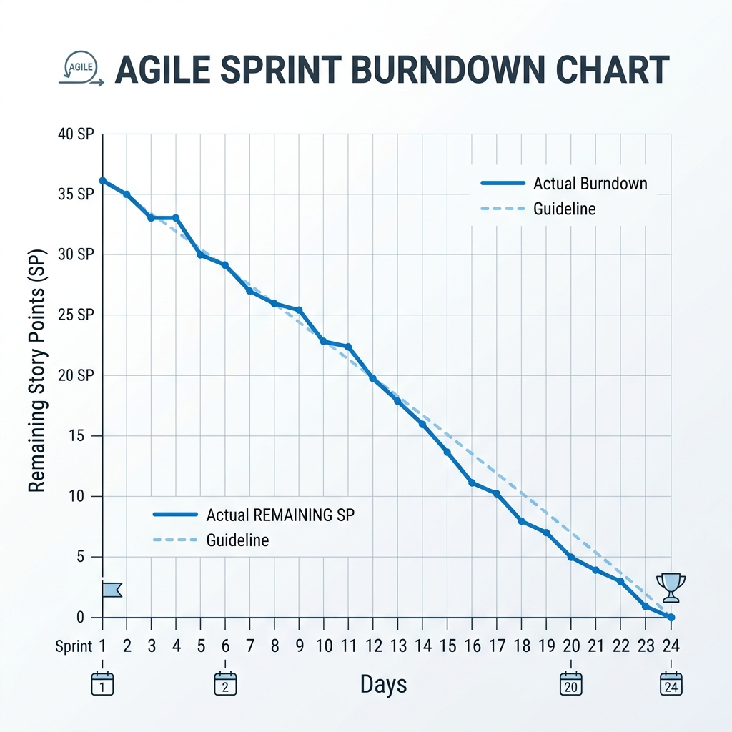
Burndown Chart Diagram

